**Indefensible Spaces**

**Chapter 3 - Redeeming the Right to Discriminate**

**Rahim Kurwa (rak@uic.edu)**

*This is a draft of Chapter 3 of my manuscript, Indefensible Spaces: Policing and the Remaking of Segregation in the Antelope Valley. The book focuses on documenting the political and social forces in Los Angeles’ Antelope Valley that, in the wake of the Great Recession, attempted to prevent Black residents from moving into the valley through the Housing Choice Voucher Program. The cities of the Antelope Valley found that, in lieu of traditional modes of racial segregation, they could use policing as a mechanism to surveil, regulate, and terrorize Black voucher renters, with the goal of evicting or otherwise forcing them out. Tenants and activists in the valley used local organizing and national fair housing litigation to resist and partially defeat this attempt to re-engineer racial segregation.*

*The preceding chapter tells the story of Black migration to the Antelope Valley and placemaking under conditions of strict residential segregation. It traces the rise of the Black town, Sun Village, and its role as a site of political struggle culminating in the fight to pass state level fair housing legislation.*

*This chapter focuses on the re-engineering of racial hierarchy in the valley after the Fair Housing Act. It traces the evolution of the relationship between race and property rights from one based on the right to exclude via discrimination to the right to exclude via policing. The road from the former to the latter was interspersed with the rise of violent white supremacy in the valley, which would shape the American right nationally in the decades to come. The chapter argues that state and mob coalesce in participatory forms of policing.*

*The chapter that follows shows how the white polity of the Antelope Valley policed Black voucher tenants and how policing functioned as a form of property.*

**Chapter Outline**

**The Fountainhead** **3**

**The Second Proposition 14** **6**

**White Politics in Disarray** **13**

**A Theory of Participatory Policing** **18**

**Redeeming the Right to Discriminate** **26**

**Images** **32**

# 

*“Take a day and walk around; Watch the Nazis run your town; Then go home and check yourself; You think we’re singing ‘bout someone else?” Lancaster’s Frank Zappa, “Plastic People.”*

In the early 1930s, Reverend Wesley A. Swift moved to the Antelope Valley. He was born in New Jersey in 1913; the son of a Methodist minister. Little is known about his life until his arrival in Lancaster in the late 1930s, but he spent some time as a Methodist clergyman, some time as a Klan emissary, and some time involved with the Anglo-Saxon Federation, the likely source of his introduction to the Christian Identity Movement. This school of thought believes that whites are the true descendants of Biblical Israelites, and that they are in the midst of an apocalyptic struggle against Jews and their non-white allies.[1] Over time, Swift began to expound on these ideas and develop Christian Identity into a popular and robust religious platform that would gain traction around the country and influence white supremacist and neo-Nazi thinking for decades.

Swift’s move to the valley was an unusual one. The region was relatively underdeveloped at the time, while Los Angeles was a hotbed of Klan activity. As Lynn Hudson documents, the Klan enjoyed police protection and coordination, and carried out vigilante and mob violence in the city.[2] The Klan also benefited from magazine and radio promotion by sympathizers, which helped it produce massive public events. One such event, a 1924 initiation ceremony in Riverside, attracted thousands of attendees and culminated in an aerial flyover in which the aircraft pulled a burning cross across the sky.[3]

Nevertheless, Swift chose the Antelope Valley. By 1946 he had established the Church of Jesus Christ-Christian in Lancaster, where he would preach the ideas of Christian Identity until 1969.[4] But Swift was also moving from developing a religious strain of white supremacy to advocating its practical political expression through violence. Tapes of his sermons extolling violent white supremacy were found in the possession of white activists bombing and terrorizing civil rights protestors in the south, and he mentored the key figure who founded the white separatist and militia movements of the 1970s and 80s. In these ways Swift bridged important parts of white supremacist politics, both geographically and temporally. But as important as Swift was, he cannot be fully understood outside the context of the valley’s own fight for racial segregation.

This chapter focuses on what happened after the Sun Village NAACP broke through the line of residential segregation that served as the fulcrum for the valley’s system of apartheid. The legal changes produced by fair housing law (as described in the previous chapter) did not just break the valley’s system of residential segregation; they represented a devaluing of white property and an abrogation of white property rights. As the valley suffered loss after loss in its efforts to ward off fair housing, it white residents could question whether the political process was worth participating in. Among them, Swift’s racist ideas could gain significant traction, and his embrace of violence offered a different way of keeping Black residents out of the valley. And so, in the years after the Fair Housing Act, white supremacy manifested through disorganized incidents of discrimination, symbolic claims to supremacy, and periods of intense violence, inculcated by leaders like Swift. Yet none of this was enough to restore the valley’s racial hierarchy.

Over time, however, these disparate attempts to re-assert segregation and hierarchy gave way to policing, not just in the form of racially oppressive law enforcement practices but also in participatory forms of policing that allowed everyday residents of the valley to join in the work of surveilling, policing, and ultimately evicting, their Black neighbors. Through these policies and practices, white polities transformed the right to exclude from a right expressed through market discrimination to a right expressed through policing. In this way they rebuilt the symbolic value of property and re-established their full sense of property rights. As the conclusion of the chapter argues, the rise of participatory policing highlights not only the role of policing in racial segregation but the value of policing as a form of property, something to be used to derogate and remove Black neighbors. Governing housing through crime has become a key way to reestablish hierarchies threatened by de-segregation in housing.

# The Fountainhead

Swift was not alone in bringing Klan activity to Los Angeles’ peripheries; the Klan was fighting a defensive struggle against Black integration in several of Los Angeles’ peripheral areas. As Black residents moved out of the city for better work and housing opportunities (including following World War II patterns of industrial development), the Klan met them with violence. Lynn Hudson documents the likely Klan involvement in the arson death of O’Day Short, an engineer who moved to Fontana to work in the new Kaiser steel mill. Swift’s thinking was of a piece with this trend.

In 1946, Swift endorsed the Klan in a speech to the American Legion in Big Bear Lake, a resort town outside Los Angeles where a series of cross burnings had recently taken place and from which five Black residents had recently been “run out.” ‘“The Klan is here in Bear Valley to stay,” Swift told the veterans’ group. “We intend to form restrictive covenants, here and elsewhere, in order to hold the line of pure Americanism.”[5] The invocation of pure Americanism was a deliberate nod to the Klan, which had used versions of the term to describe its goals in public flyers,[6] songs,[7] and writings by its leaders.[8]

Swift’s work was soon noticed by California Attorney General Robert Kenny, who began investigating the revival of the Klan with the goal of shutting down the organization. Although Kenny found that Swift had been purchasing weapons for nearly a decade, he did not find grounds to prosecute or otherwise penalize Swift. But the investigation did reveal that a Sheriff’s deputy had been serving as a bodyguard for Swift and his mentor, Gerald L.K. Smith. Smith had been a devotee of Huey Long, and through his involvement with Long he developed his supremacist ideas. After Long’s death, Swift turned to recreating the America First Committee as the America First Party. He began a national magazine called “The Cross and the Flag,” and eventually took over Father Charles Coughlin’s radio broadcasts. Smith brought Swift to speak at rallies in Cleveland, Denver, and Minneapolis in the mid 1940s. After they both settled in Lancaster, they founded the Christian Defense League and the California Rangers, paramilitary organizations. Swift and Smith used Lancaster as a home base of sorts, driving down to Los Angeles to give speeches extolling anti-Semitism and white supremacy.[9]

Swift began traveling to spread his message and drum up support. He visited Utah, urging his audiences to purchase guns and follow the lead of those in Los Angeles, where he claimed that 20,000 men were ready to aid in a war against communists.[10] His growing profile helped him raise $10,000 from various white Christian organizations in 1949.[11] A 1965 investigation by Los Angeles radio station KLAC summarized Swift’s new stature as follows:

*“Swift's church is not, we've found, the only source of extremist thought, but is generally regarded by those of the Klan mentality to be purest...the very gospel. His mixture of biblical and historical distortion...fortune-telling and star-gazing, coupled with a smattering of legitimate conservative politics, and rolled from a silver tongue has become, as we said earlier...the fountainhead for extremist thought and action in California.”[12]*

By the 1960s, Swift had gained national prominence. He had a weekly radio show in Los Angeles called “Crusade for Christ,” and spoke frequently at the Embassy Auditorium in Downtown Los Angeles and the Hollywood Womens’ Club. He traveled to Oklahoma in 1958, speaking to “Citizens Councils.” In November of 1963, in Lancaster, Swift presided over the first meeting of the Christian Knights of the Invisible Empire. At the meeting, where 38 members were admitted to the group, Swift explained that the organization was for all intents and purposes, the same as the Klan, but had to operate under a different name now that the Klan had been outlawed in California. On November 5th, CKIE met to discuss plans to burn down a television repair shop operated by a Black businessman on the outskirts of Lancaster (in Quartz Hill). The shop was burned down using Molotov cocktails on November 10th, 1963. By 1964, Swift had turned over leadership of CKIE to William Porter Gale, a retired army colonel who had served in the Philippines. Gale returned to the United States as an active white supremacist, joining the Aryan Nations and eventually founding the Posse Comitatus.

Swift’s focus turned to recording and distributing tapes of his sermons. Although he had traveled across the South to rally against civil rights, even becoming a member of the KKK in Florida, recording and distributing these proved a much more effective mode of influence.[13] FBI files on Swift include numerous incident reports in which suspected white supremacists arrested in the south were found in possession of Swift’s tapes. “Reverend Connie Lynch carried [Wesley Swift’s] message to the Klansmen battling civil rights marchers in St. Augustine, Florida,” the site of a years-long confrontation between Black activists campaigning for the city to conform to existing Civil Rights laws, and the Klan who terrorized them for it. Elsewhere in the South, Sam Bowers, the leader of the Klan splinter group the White Knights, was reported to have “listened to Wesley Smith’s Christian Identity tapes in Mississippi.” Bowers was one of the key perpetrators of the 1963 murders of James Chaney, Andrew Goodman, and Michael Schwerner. Bowers’ disciple in the White Knights, Thomas Tarrants, partnered with fellow Klan member Kathy Ainsworth to attempt a bombing of a Jewish synagogue in 1968. Ainsworth, Chalmers reports, “had listened to Swift’s tapes in her roommate’s Mississippi home.”[14] The two were confronted by the FBI, which killed Ainsworth and injured Tarrants, who went on to repent for his participation in the Klan. Swift’s long reach from Southern California to the Southern United States was a sort of perverse parallel to the SAV NAACP’s efforts to fundraise for the Mississippi Freedom Fund. In the decades to come, Swift and his ideas would continue to carry weight on the American right.

# The Second Proposition 14

While the Klan used physical violence to hold the line of pure Americanism, the California Real Estate Association used the law. It had successfully stopped the first Proposition 14, which would have driven state funds towards public housing construction. It then passed Article 34 which added new barriers to building public housing anywhere in the state. Now, as Daniel Martinez HoSang documents, conservative forces in the Antelope Valley played those notes again in their 1960s fights to preserve the right for property owners to discriminate against tenants and purchasers.[15]

As reported by the *Antelope Valley Press*, in 1963, California Real Estate Association president L.H. Wilson gave a talk in which he declared “It is time to launch a new crusade – a crusade for freedom to rescue the rights of the new ‘forgotten man.’ The cold war over discrimination has passed him by.” He continued,

*“Militant minorities have organized and vocalized for ‘equal rights’…until ‘equal rights’ have almost become ‘special privilege’ and this forgotten man lies neglected. He is the great, patient, passive majority, the working majority that pays for expensive government. He is the American small property owner.”*

Wilson went on to introduce a campaign for a Property Owner’s Bill of Rights, intended to head off the Rumford Act (California’s 1963 statewide fair housing law) before it was passed. That the response to a ban on discrimination was to assert that property rights were being diminished is to concede that racial discrimination was an essential part of the white conception of property rights. The rights CREA outlined included,

1. *“The right to privacy.*
2. *The right to choose his own friends.*
3. *The right to own and operate property according to his own dictates.*
4. *The right to occupy, administer, and dispose of property without legal interference in accordance with the dictates of his conscience.*
5. *The right to equal rights in the enjoyment of property without interference by any laws giving special privilege to any group or groups.*
6. *The right to maintain congenial surroundings for tenants.*
7. *The right to contract with a real estate broker or other legal representative of his choice and to authorize him to act for him according to his instructions.*
8. *The right to determine the acceptability and desirability of any prospective buyer of his property.*
9. *The right of the Senior Citizens and other Americans to choose congenial tenants in any properties they own - to maintain the stability and security of their income. These property owners should not be obligated to require their tenants to accept each other discriminately, giving rise to inter-group relations by coercion of law.*
10. *The right to enjoy the freedom to embrace, reject, deal or not deal with others.”[16]*

The document was written in an especially defensive mode - hiding the right to discriminate amongst items like the right to choose one’s friends. That the right to discriminate against Black residents could not be forthrightly stated is an indication of the rear-guard action being fought by white property interests by the 1960s. Yet as the Rumford bill came closer to a vote, its opponent’s complaints grew louder and clearer. Writing in the *San Bernardino County Sun*, David Lawrence suggested that banning discrimination was not just a diminishment of property rights, but actually constituted a confiscation of property itself:

*“The Constitution plainly says that no person shall be deprived of his property without due process of law, “nor shall private property be taken for public use, without just compensation.” Do the suggested restrictions mean that if the government supervises the sale of property, it is, in effect, “seizing” private homes?”[17]*

The Rumford Act passed anyway. Not long after it did, California Real Estate Association president Arthur S. Leitch spoke to a regional audience of realtors including more than two dozen from the Antelope Valley. On behalf of CREA, he warned that the state would be “set back 50 years” if the Rumford Fair Housing Act was allowed to stand. whipping up support for a new Proposition 14 that would overturn it in defense of individual rights – not the right to purchase or rent housing, but to rent or sell it in discriminatory manner. Proposition 14 had taken elements of CREA’s crude Property Owners Bill of Rights and turned it into legislative language securing property owner’s unfettered rights to discriminate.

In advocating for Proposition 14, CREA leaders repeated the association between discrimination and rights. In a letter to the editor responding to an earlier column published in the *Los Gatos Times/Saratoga Observer* in April 1964, Shelley Williams, the president of the Los Gatos-Saratoga Board of Realtors wrote, “In your judgment, the CREA initiative places property values over human values. In our judgment, owning and disposing of property, in a free society, is a human right.”[18] These words illuminate the conjoined nature of racism and capitalism in the context of housing markets. The ability to dispose property (ie: to sell it) is one of the characteristics which help define something as property, and so when a realtor exalts that right and demands it be unfettered by anti-discrimination law, that represents the inscription of discrimination as a property right. To limit a property owner’s ability to racially discriminate was to diminish their property, circumscribe their ability to use and sell it, and diminish its market value. Though Proposition 14 was often framed in non-racial terms or as a response to “forced” housing, its genesis, and the regular return to defending the right to discriminate illustrate that discrimination was fundamental to white property rights. As extraordinary as Williams’ claim was (that the right to discriminate in housing was on par with other human rights), it illustrates the reality that the passage of fair housing laws would not be the end of the story of racial segregation in housing - no polity which viewed the right to discriminate as so important could simply accept the loss of that right without a fight.

The South Antelope Valley NAACP countered CREA’s Proposition 14 campaign with their own organizing. In May, the Southern Area Conference of the NAACP met in Littlerock to map out organizing plans. Ruby Williams, the Pasadena NAACP leader, visited the Unitarian-Universalist Fellowship of the Antelope Valley to speak on civil rights,[19] campaigners took out an ad in the SAVP, and tabled for ‘No on Prop 14’ at the Antelope Valley Fair and organized an essay contest whose prizes included a typewriter and personal letter of congratulations from Governor Edmund Brown.[20] And in October, Sun Village NAACP held a voting workshop in advance of the November election.

While the first Proposition 14 (discussed in Chapter 2) ended in a 2-1 defeat of the pro-public housing referendum, the second ended with CREA having nullified the Rumford Fair Housing Act by a 2-1 margin.[21] The measure passed with 65% of the vote statewide, and 67% of the vote in Los Angeles County. But in Palmdale, voters approved the measure with a landslide 79% yes vote.[22]

CREA turned to battling the legal challenges to Proposition 14 that rapidly emerged. The *Antelope Valley Press* reported that between its passage in November 1964 and May 1965, CREA was fighting eight legal challenges to Proposition 14, and warning of a ninth. In July, the paper printed CREA’s opposition to comments made by the State Fair Employment Practices Commission that challenged CREA’s practices of including racially restrictive housing listings in its real estate listing services.[23] As the legal challenges mounted, CREA floated new ideas like a new initiative more directly aimed at overturning the Rumford Fair Housing Act.

Ultimately, Proposition 14 was overturned by the California Supreme Court in 1966. CREA reacted by petitioning the Supreme Court to review the ruling,[24] formally endorsing another initiative to repeal the Rumford Act in 1966,[25] and urging the California Attorney General to weigh in with the court as well.[26] Meanwhile, local realtors mobilized to stop fair housing legislation at the federal level. The Civil Rights Bill of 1966, which principally sought to defend civil rights workers from violence in the South, was effectively killed in the Senate over its fair housing provision (a national version of the Rumford Act).[27] In fall 1966, Joe Rodgers, head of the Property Owners Division of the Antelope Valley Board of Realtors, led a fundraising drive to support the National Association of Real Estate Boards (NAREB)’s campaign to prevent the fair housing provision from being raised in the next congressional session.[28]

Sun Village spent those years fighting for the right to live anywhere in the valley while also continuing to build Sun Village. In 1964, Sun Village Chamber of Commerce began recruiting investors to build $8,000-$10,000 homes ($66,500 in 2020 dollars) in the sub-division.[29] The low-cost homes were envisioned in circular plots with space for a children’s playground and swimming pool – amenities Black residents of the Antelope Valley were historically denied. In 1965, after years of effort, Sun Village residents succeeded in getting Los Angeles County to install street lights at 37 Sun Village intersections.[30] Jackie Robinson Park opened to fanfare in 1965 and was running full schedules of public events soon thereafter. In a report to the Chamber of Commerce at the start of 1967, Daisy Gibson noted that Sun Village had built more homes in 1966 than in 1965, and had very few vacancies. Other homes were being remodeled, and additional water mains had been installed to extend municipal services to new residents. The growing population of Sun Village (approximately 2,000 according to Sebastian Rotella[31]) needed improved roads, and the Chamber planned to spend 1967 focused on that issue, and continuing to build up social services, including Head Start programs. At Jackie Robinson Park, the Chamber had gotten crosswalks installed to increase pedestrian safety, and begun adult literacy and math programs as well.

These steps, however, weighed against larger political headwinds against civil rights and social services. Although the courts had struck down Proposition 14, its passage by overwhelming margins was unforgettable. In a February 1967 address to the Sun Village NAACP, Mrs. Tarea Pittman,[32] the NAACP’s national Special Contribution Fund Director, decried “trouble” in the Antelope Valley and California, warning of Governor Ronald Reagan’s cutbacks to social spending in high poverty areas and his call for the repeal of the Rumford Fair Housing Act. And she reminded her audience that the state’s electorate voted overwhelmingly against civil rights in the Proposition 14 fight.[33]

Pittman’s warnings were prescient. In October, at CREA’s statewide convention held at the First Methodist Church in Los Angeles, the organization announced its push to get the state legislature to repeal the Rumford Act and replace it with a commission which would remedy racial discrimination in housing through education and counseling. Governor Reagan keynoted the convention, opening his talk by reaffirming the “human rights” of all people “regardless of race, color, religion or creed.” Reagan went on to say, “Make no mistake about it. There are no such things as property rights in the connection used by some. There are only human rights and some of those human rights are the rights involving property. These rights affect all our citizens, regardless of their color, their race or their social status.”[34] Reagan went on to reaffirm his opposition to the Rumford Fair Housing Act, situating it as an expression of a consistent principle of respect for property rights rather than a preference for racial discrimination, but spent much of his speech warning CREA that it would not be easy to repeal, only to claw back one inch at a time.

How far CREA and Reagan would have gotten with these efforts to repeal the Rumford Act or render it toothless is unknown. The assassination of Martin Luther King Jr. on April 4th sent shockwaves through American society. At the state level, CREA announced on April 7th that it would not pursue a new initiative to repeal Rumford. The fair housing provisions that had been stalled in 1966 were reintroduced and voted on within days. Although it passed by a large margin in the House, the Antelope Valley’s congressional representative, Ed Reinecke, was one of 14 Republicans from California’s congressional delegation to vote against the bill. Reinecke issued a statement reading in part:

*“I favor meaningful civil rights legislation but the time has come when we must stop kidding our minority populations. The new Civil Rights Bill, hastily strong-armed through the unusual house vote yesterday, contained many, many imperfections, particularly concerning the open housing clauses, which perhaps could have been purified in a House-Senate conference...House members deserve the right to give the important matter their thoughtful consideration and suggestions outside the atmosphere of riot and unrest.”[35]*

President Johnson signed the bill on April 11th. In the span of a week white property owners saw their worlds turn upside down. Federal law now prohibited the use and disposition of property in ways that were fundamental to the established understanding of property itself. The Antelope Valley re-elected Reinecke in 1968 and Reagan appointed him Lieutenant Governor of California in 1969.[36] Reinecke’s political career ended after he was convicted of perjury related to the Watergate scandal in 1974, but his vote against the Fair Housing Act was an indicator of the local politics of the Antelope Valley.

As the 1960s ended, CREA moved on to the new political touchstones of the right - its Make America Better program focused on fear mongering about urban crime, poor schools, and high taxes.[37] The Antelope Valley Board of Realtors made peace publicly with fair housing, blaming property owners and real estate agents for not getting the message that fair housing was the law of the land.

Other evidence seemed to confirm a change. Lynole Williams, who grew up on Edwards Air Force Base, recalled that in the 1980s Black children and families from the base would come to the cities to buy groceries, shop, and eat. When they were mistreated or denied service in the cities, the Air Force would threaten local business with an informal boycott. “The military base basically told them, okay, you mistreat ours, they're not coming shopping, they're not getting gas...our people aren't coming and they know that if our people aren’t coming...this little town is going to dry up.” The next decade saw more examples of progress. Bishop Henry Hearns was elected to the Lancaster City Council in 1990, and became the city’s first Black mayor in 1991.[38]

Perhaps the greatest sign for valley residents came on Page 2 of the October 11, 1970 edition of the Antelope Valley Press. At the top of the page the paper announced, “Dr. Wesley Swift, Noted Conservative Leader, Dies.” Swift had been in poor health, and finally succumbed to a heart attack while convalescing in Mexico.[39] Below the fold, the paper reported, “Picture of Angela Davis Stirs College Controversy,” explaining that a drawing of Davis placed in the Black Studies display case had been taken down by Antelope Valley College’s administration. The incident, eventually reversed by dean of student activities Bill Montamble, sparked a free speech controversy, with the campus’ Black Congress arguing that the censorship was a “direct attack on the black people of the campus.”[40]

That Swift was gone and the Free Angela Davis movement had arrived in the valley signified clearly that the balance of political power in the valley had shifted. White students at Antelope Valley College resorted

# White Politics in Disarray

The tide seemed to be turning. In 1970, Wesley Swift died of a heart attack while in Mexico. His body was returned to Lancaster and his funeral service was held at Mumaw Funeral Home. He left three legacies. First, Swift had authored the religious foundations of white nationalism that continued to influence organizations around the country decades after his death. Reports about Swift link him to a dizzying array of right wing groups during his lifetime, to some degree a product of his penchant for fabrication but also a reflection of how deeply influential he was on the evolution of the right outside of the Republican Party.

Second, Swift served as a bridge between the depression-era right and its more contemporary stewards. Through his mentor Gerald L.K. Smith he was influenced by Henry Ford and Father Coughlin; and through his mentorship of Richard Grint Butler and William Porter Gale he influenced the next generation of the white supremacist, militia, and neo-Nazi movement in America. Butler was a Lockheed employee in Lancaster who Swift mentored into a Christian Identity pastor, and who served as the head of the Christian Defense League from 1962 to 1965. After Swift’s passing Butler moved to Idaho, founding the Aryan Nations organization and opening a new branch of Swift’s church. Butler spearheaded the white separatist movement that hoped to create a white homeland in the Northwest, building a compound that would become an international meeting site for white supremacists and a font for violent incidents around the country, including the notorious Ruby Ridge standoff.[41]

Third, although the printed record of his influence within Lancaster is thin, he surely influenced his community at home, including the followers who attended his church, and the families and friends they influenced in their own lives. Whether they knew it or not, children born in the year he died went on to revive American Nazism in Lancaster in the late 1980s and early 1990s.[42] To show how the valley got there, I trace the afterlives of the segregated system that produced Sun Village. These were to be seen in employment, education, and housing - spaces where the valley re-engineered hierarchy among a less spatially separate Black and white community. In what follows, I trace the disparate and disorganized but nonetheless powerful incidents and structures of discrimination that arose in the 1970s and 1980s. After the valley’s economy collapsed in the early 1990s, I trace two social processes that followed - the rise of white supremacist violence and the growth of racist policing, showing how they were re-consolidated into a participatory form of policing in the 2000s.

By the 1970s, the employment situation in the valley had been entrenched in racial discrimination. In particular, defense industry employers were widely understood to be discriminating against Black employees and tracking them into low-level jobs. In 1977, the Antelope Valley NAACP pushed the issue far enough to secure a meeting with the Edwards Air Force Base’s administration. Attorneys and advocates pressed the Flight Test Center on systematic and widespread discrimination, charging that the center’s workforce comprised only 4% Black workers (86 of 2,300 people), who were completely shut out of top-level policy and decision-making positions. Other Black employees reported harassment and demoralization linked to being denied promotions over the course of several decades, while white employees enjoyed steady rises in status.[43] At various times, papers reported concessions by the main defense industry employers, but the work was piecemeal and never appeared satisfactory.

The educational system was also a site of near constant battles over educational content, discrimination against Black students, and racist symbology. In the 1960s, public criticism of California’s textbooks mounted after CORE criticized the state’s textbooks for their demeaning portrayals of African Americans (for example, the books portrayed slaves as happy). New educational materials were written and introduced to California schools, intended to better integrate race into public education. *Land of the Free* was one such textbook, written in part by John Hope Franklin. Its appearance in California classrooms in the late 1960s was met with vigorous conservative efforts to remove it.[44] While protests against the textbook originated in Los Angeles, they spread as north as Tuolumne and as south as San Diego. They also reached Palmdale and the Keppel Union School District. While the protests’ outcomes are unclear, they illustrate the continuities between the valley’s right wing politics and the broader wave of conservative mobilization across the southland.[45] And they presaged ongoing battles at all levels of public education.

The Angela Davis controversy at Antelope Valley College that occurred later that decade was only part of a longer battle in the educational system. The year prior, students had joined the national Vietnam War Moratorium protests, and opposition to the war and the valley’s deep involvement in it continued to bubble up on campus afterwards. Though campus administrators appeared to manage these controversies as they arose, the removal of the Davis poster sparked reactions that could not be contained. The student government voted to invite Black Panther representatives to speak on campus, as a way to make up for the administration’s censorship. In a telling reaction, some members of the student government proposed inviting members of the American Nazi Party, for balance. Administrators considered whether they had to allow the student government to invite any guest speakers at all. Meanwhile, public backlash grew, with protests being mounted in opposition to even the consideration of inviting a Black Panther speaker. At one, a mother of an AVC student was reported to have shouted, “If those black bastards come here, I’ll be on the front lines with a gun!” Finding that they could not legally bar the student government from inviting a Black Panther speaker, the administration instead took over the event, and reorganized it so as to bury the Black Panther speaker amidst speakers from the Congress of Racial Equality, NAACP, and Urban League.[46]

In the 1980s, Quartz Hill High School and the nearby Quartz Hill Elementary School adopted Confederate mascots and school symbols. The high school mascot, a Johnny Rebel figure carrying a Confederate flag and sword, was printed on clothing, stationary, and other school materials, while the elementary school labeled itself “Home of the Junior Rebels”.[47] Until the late 1980s, the high school kept a homecoming tradition known as “slave day” in which “students auctioned off other students to raise money for clubs.”[48] By 1995, the issue rose to public prominence as students, community members, and the Antelope Valley NAACP (led by Linda Thompson Taylor) organized to persuade the school board to mandate changes at the high school, later focusing on the elementary school’s “Junior Rebels” iconography. The high school dropped the confederate flag and changed its letterhead the following year, though the Johnny Rebel mascot and Rebels school name lasted until June 2020.[49]

And in housing, the dynamic flipped from a more explicit and publicly understood form of racial segregation to one hidden in the rental process. In the 1980s, Investment Concepts, Inc. was alleged to have developed a system of racially discriminating against Black renters. Employees were asked to mark rental applications made by Black applicants with a smiley face, so they could later be denied. A whistleblower, Annette Caracciolo, refused, and claimed she was fired for it, sparking a group of employees to file the lawsuit. Perhaps most strikingly, the employees who filed the complaint after refusing to participate in the marking scheme stated that every lawyer they contacted in the Antelope Valley declined to take their case. The case was taken by Bert Voorhees, whose team was eventually contacted “by a little more than 100 Blacks and Latinos who [the company] turned down for housing.”

One mixed race couple, the Reeses, recounted their experience when applying for housing in one of the company’s properties. When Anna, who was white, applied, she was told of several openings, but when she returned the next day with her husband, Johnnie, who was Black, those openings suddenly disappeared. Investment Concepts settled for 1.1 million, the largest fair housing settlement in the country at the time, and a sum which included funds to fair housing groups for the purpose of auditing rental practices for evidence of similar discriminatory tactics.[50]

These types of racial discrimination served the ends of re-engineering racial hierarchy inside the Antelope Valley. Before 1968, hierarchy was achieved by keeping Black residents outside Lancaster and Palmdale; after 1968 it needed to be achieved by making them unequal within Lancaster and Palmdale. As vicious as these tactics were, they were superseded by much more visceral and violent forms of white supremacy that emerged as the valley lost its economic engine and entered a period of sustained decline.

The end of the Cold War marked the end of the valley’s empire-fueled prosperity. The early 1990s saw a major recession in Southern California, driven by the decline in aerospace and defense industry activity. This marked a turning point in the valley’s economic relationship to the rest of Los Angeles County, transforming it from an area that was wealthier than the rest of the county to one that was increasingly poorer. As William Finnegan described the recession,

*“Los Angeles alone lost more than half a million jobs, and property values throughout the region collapsed. Few places were hit harder than the Antelope Valley. Housing prices fell by as much as 50 percent, land prices by as much as 90 percent. Abandoned housing tracts began to dot the subdivided desert. Boarded-up shopping centers and bankrupt school districts followed, along with a wave of personal financial disasters so severe that USA Today dubbed Palmdale “the foreclosure capital of California.”[51]*

Yet despite this economic collapse, the 1980s and early 1990s saw the valley’s population continue to grow. This growth included a slow but steady rise in the Black population of the Antelope Valley. As Finnegan describes it,

*“Between 1990 and 1994, Palmdale was the second-fastest-growing city in the United States, Lancaster the sixth. As a rule, the valley’s newest residents were poorer and darker than their predecessors, lived in more crowded lodgings – new home construction having essentially stopped – and were more likely to rent. Still, the valley remained, in a county where whites were a minority, overwhelmingly white (68 percent), home-owning, and dominated politically by conservative Republicans of the pro-growth, anti-tax stripe”.[52]*

Finnegan describes the contradictory trends of population growth and economic decline as an environment in which “widespread white insecurity and downward mobility intersected with significant black and Latino upward mobility – an intersection that made for an altogether different kind of social friction”.[53] Davis described the public’s attitude as follows: In their increasingly angry view, the landrush since 1984 has only brought traffic jams, smog, rising crime, job competition, noise, soil erosion, a water shortage and the attrition of a distinctively countrified lifestyle”.[54]

How the Antelope Valley reacted to these rapid changes exemplified a social process that has occurred throughout the nation. In the valley as in the nation, governments turned to policing – not just the policing of law enforcement agencies or local governments, but also a participatory form of policing which enfolded white residents into the work of surveilling, reporting on, and punishing their Black neighbors. For the valley, participatory policing would become a way to empower its favored residents while also slowing or reversing the racial integration of its once white neighborhoods. As the rest of this chapter and the following detail, this is one important way that, in the Antelope Valley and places across the country, policing came to be a fulcrum of racial segregation.

# A Theory of Participatory Policing

To see what a shift this is from prior mechanisms of racial segregation, consider what we know about how racial segregation has operated in the 20th century, not just in Los Angeles but across the nation. Before the more notorious practices of redlining, restrictive covenants, and blockbusting, white society used collective action to enforce and maintain racial segregation. Whites discouraged each other from renting or selling property to Black residents. Doing so would incur steep social sanctions that outweighed any financial benefit. Over time, however, white collective capacity waned. It is in these moments that white polities turned to their local governments to pass municipal segregation ordinances which would codify as law a set of white preferences that white society could no longer enforce on its own. This process is referred to by economists Werner Troeskin and Randall Walsh as substitution, whereby one waning mechanism of segregation is replaced by another.[55] Ultimately, it mattered little that segregation ordinances were ruled unconstitutional because they were replaced by restrictive covenants, and once those were hobbled, they were obviated by real estate association rules that concretized segregation, and onwards through history.

What is important to note about this framework is that substitution can explain shifts between categorically different mechanisms of segregation. At times, states may step in for civil society, but the process can also operate the other way, with individuals filling the gap left by governments and social institutions when they can no longer segregate. Consider the decades after the passage of the Fair Housing Act. As Jeannine Bell documents, as pathways to maintain segregation in the country waned in the wake of the Fair Housing Act, individual and collective violence rose to replace it.[56] Conducted by individual white perpetrators in response to Black residents moving into white neighborhoods, move-in violence became the third most common form of “hate crime” in Boston during one 1980s study.[57] Though the city coded these incidents as individual hate crimes, it is perhaps more accurate to think of them not as individual acts nor as hate crimes, but instead as a form of mass segregationist politics expressed through violence in ways that are recognizable throughout the history of racial residential segregation. Between 1990 and 2010, Bell found 455 of these incidents across the country, which have taken the form of vandalism, harassment, verbal threats, cross burnings, arson, physical attacks, shootings, and homicides within days, weeks, or months of a Black family’s move to a predominantly or all-white neighborhood.[58]

But as the balance of this chapter argues, substitution is an incomplete way of understanding how policing fits into the matrix of forces that have created and maintained racial segregation in the United States. In what follows, I trace two distinct strategies of re-asserting white supremacy in the Antelope Valley during the 1990s and 2000s. The first was white communal violence, both physical and symbolic, which aimed to terrorize Black residents out of the valley. The second was repressive policing that humiliated, brutalized, and impoverished Black residents within the valley, denying them the equal treatment that the end of segregation had promised. These distinct types of racial oppression were synthesized through participatory forms of policing, whereby whites are empowered, encouraged, and rewarded for surveilling and policing, and ultimately evicting, their Black neighbors. I trace an evolution of the region’s crude attempts to police housing in the early 1990s to its more sophisticated adoption of crime-free housing and nuisance ordinances that spread across the country in the 1990s and 2000s, formally putting the power of policing, eviction, and racial segregation in the hands of aggrieved white residents. Such a form of policing represents not so much a substitution of segregation strategies but a synthesis of individual and state action. This synthesis is legible from a property framework - one that reads individual participation in policing as a form of acquiring a social status and set of powers that are unavailable to others. Such a framework is not necessarily new – it constitutes a contemporary legacy of what K. Sue Park describes as the state’s delegation of “the racial violence of creating and maintaining property in lands and people—and the racial order that sustained the state—to private interests.”[59]

The Antelope Valley’s neo-Nazi movement is the first place to start. While earlier decades saw the valley’s social institutions and corporate actors trying to raise the gangplanks through discrimination, the 1990s saw a rise in white violence from young people. This process was documented first hand by William Finnegan in his narrative non-fiction book *Cold New World*, which chronicles the social consequences of the valley’s de-development in the 1990s – specifically the rapid growth of skinhead and white supremacist groups among the valley’s white youth. Finnegan described young people addicted to crystal methamphetamine engaging in petty burglaries and forming gangs in an “apocalyptic” environment where they saw no economic future for themselves. As Belew documents, however, the processes Finnegan chronicles in the valley were repplicating across the country as white power leaders sought to incorporate skinheads into the white power movement.[60]

The gangs rampaged throughout the valley in the 1990s. A group of Nazi Low Riders threatened to blow up a Lancaster coffee shop because it served minorities; a Latinx individual was beaten outside a 7-Eleven; a group of white supremacist students stabbed a Black student at Antelope Valley High School; Black motorists were shot by three young white men in a racially motivated attack; and a homeless Black man named Milton Walker Jr. was brutally murdered by three avowed white supremacists in 1995, at least one of whom was a member of the Nazi Low Riders. That final case was closed after a cursory investigation by the Los Angeles County Sheriff’s Office but reopened two years later after a federal intervention discovered witnesses to the case and evidence of racial motivation.[61] In 1996, racially motivated hate crimes against Black men in Los Angeles County were reported to have been 50% higher than in 1995, with a cluster of crimes located in the Antelope Valley. A summary of the report stated, “the increase ‘does not say it had become open season on African Americans’ but reflects increased hostility as blacks move to areas populated by other ethnic groups”.[62]

In 1993, two young white men from Lancaster planted a 6-foot-tall, 4-foot-wide wooden cross in the front yard of Eleanor and James Pate (age 63 and 70, respectively). The cross was covered in “KKK” and white supremacist slurs and prompted an NAACP request to prosecute the incident as a hate crime. In 1994, “vile racist flyers exhorting their readers to violence in defense of a white and pure nation” were found throughout Los Angeles County, especially in San Fernando Valley, Santa Clarita, and the Antelope Valley. The fliers often contained anti-Black, anti-immigrant, and anti-Semitic sentiments and were made by groups like “White Aryan Resistance.” They encouraged readers to take action, join white supremacist groups, and donate money to such groups, and were distributed in grocery stores and shopping centers in the Antelope Valley and nearby areas.[63]

While it may be tempting to see these young skinheads as exceptional, alienated, or a product of the valley’s economic decline, in some ways they were simply responding to the valley’s politics, echoing the ideas and attitudes printed in the newspaper and voiced by their political representatives. And whether they knew it or not, they were following not only in the region’s long history of white supremacist organizing, but also in the national trend of skinheads as the vanguard of the white power movement in the late 1980s and early 1990s.

The local-national flows of white power poltics continued after the police beatings of Rodney King, and the subsequent uprisings in response to the acquittal of the officers. A Washington state cartoonist named Chris Britt drew a cartoon depicting a Ku Klux Klan member lynching a Black man while holding a newspaper with a headline about the acquittal of the men who attacked white truck drivery Reginald Denny. Britt was part of a 300-paper syndication network, allowing his work to be picked up by newspapers around the country if they so chose. It was picked up in an Iowa paper in September of 1993, generating substantial controversy, and then published again in November 1993 by the *Antelope Valley Press*. The publication provoked outrage across the Antelope Valley, culminating in, among other things, a 40-person protest in Palmdale. The paper’s editor issued a rationalization of the cartoon and claimed not to have been asked to apologize, despite the protest.

The poison coursing through the body politic wasn’t limited to anti-Blackness alone. In the same year as the *Antelope Valley Press* published the lynching comic,State Assemblyman William J. (Pete) Knight, representing Palmdale, targeted the Antelope Valley’s growing Latino population by writing and distributing an anti-immigrant poem. Called “I Love America,” the five-stanza poem written in a mocking style tells the story of an immigrant who crosses the border illegally, goes on welfare, asks friends to help invade an Anglo neighborhood, and jokes that Americans are crazy to support them with their taxes.[64] Knight publicized the poem widely, and even read it into the California Legislative Record in 1993. Its lyrics included:

*Write to friends in motherland, tell them come as fast as can…*

*They come in rags and Chebby trucks, I buy big house with welfare bucks…*

*Everything is mucho good, soon we own the neighborhood.*

*We have a hobby, it’s called breeding.*

*Welfare pay for baby feeding…*

*We think America damn good place.*

*Too damn good for white man race.*[65]

Knight’s actions incited a major controversy in the region and contributed to the wave of nativist hostility during the early 1990s. But while his behavior generated significant opposition, Knight also aroused a groundswell of support, which became evident when a local talk radio show covering the issue found its phone lines overwhelmed with calls in support of his views. In 1994, State Senator Don Rogers, an Antelope Valley Republican, became the subject of another controversy when it came to light that he was scheduled to speak at the annual banquet of a white supremacist organization called Jubilee. Jubilee was part of the Christian Identity movement, which endorsed white supremacy and believed non-Northern European races were “mud people,” the same phrase found on many of the fliers distributed throughout the valley in that year. Rogers was scheduled to speak alongside a former leader of the KKK and a member of the Aryan Nation, but refused to cancel the talk, claiming that the organization was composed of patriotic Americans simply “working to preserve and restore individual rights and freedoms”.[66]

It took until 1997 for the federal government to intervene in the valley’s white supremacist violence. Only thirteen hate crimes cases had been prosecuted in the Antelope Valley between 1993 and 1997. In 1997, the Federal Bureau of Investigation reported 17 race-bias incidents in Lancaster, a figure that was surpassed by only six cities in the state, each of which had populations at least three times larger than Lancaster’s. Federal investigators told the *Los Angeles Times* they were targeting three groups in the Antelope Valley – the Nazi Low Riders, Palmdale Peckerwoods, and Metal Minds. Local police estimated that the Nazi Low Riders had between 200 and 300 members as of 1999, when two of their members, Shaun Broderick and Christopher Crawford, beat a Black Wal-Mart employee outside the store.[67]

Federal authorities said they were “concerned that white supremacists [were] trying to frighten minorities away from the area’s working-class suburbs”.[68] But Lancaster mayor Frank Roberts refused to acknowledge it was a problem. Roberts had first been elected to the city council in 1992, after serving, among other roles, as Dean of Administration of Justice and Criminology at Antelope Valley College.[69] Now mayor, Roberts turned the anti-gang crackdown from one focused on white supremacists to one focused on Black youth. In 1998 the city announced it had secured $1.5 million in funding for a Gang Violence Suppression program that marked the start of a decade of anti-Black politics articulated through the controlling image of the Black gang member.[70] Two years later, a Black family in Palmdale awoke to find racial slurs and swastikas written in chalk on their driveway, and the tires on their car slashed. Later that day in Lancaster, a six foot swastika was chemically burned into the grass at a park where a multi-ethnic celebration was about to be held.[71]

Lancaster’s turn towards policing Black and Latinx residents of the Antelope Valley was only partial. Lacking its own police department, the city, like Palmdale, contracted with the Los Angeles Sheriff’s Department (LASD) for police services. The valley was an assignment with its benefits and drawbacks - far from Los Angeles and not prestigious, but a place where law enforcement could do as it pleased with little oversight. The deputies sent to the valley were sometimes members of two notorious LASD gangs (the Rattlesnakes and the Cowboys).[72] As a Department of Justice investigation reported in 2013, they sorted the valley by race and targeted Black and Latinx residents for additional stops, searches, ill treatment, excessive use of force, and property seizures. This policing was designed to impoverish, incarcerate, demean, and discourage Black residents. It proceeded roughly as follows: discriminatory stops led to discriminatory searches, as well as unconstitutional practices during stops and use of force against people who had been stopped. When police took Black citizens into custody, they often used excessive force against them, and seized their vehicles, imposing further financial hardship on them.

Black and Latinx pedestrians in Palmdale were stopped at rates 33% higher than they would be if there were no racial differences in policing. The figure was even higher in Lancaster, at 38.5%.[73] These discriminatory pedestrian stops were entry points to further discriminatory treatment. As the DOJ summarized, the offenses where law enforcement has the greatest amount of discretion were the offenses with the largest racial disparities. Black residents were disproportionately stopped for, “crossing against a traffic light, jaywalking, failing to yield right of way, or walking on the wrong side of the street.” The DOJ further found that Black pedestrians in Lancaster were 25% more likely than their white counterparts to be stopped for a discretionary offense. “A large number of these stops, for minor offenses such as jaywalking, also resulted in questionable pat downs and consent searches.”

While the DOJ did not find racial disparities in vehicular stops, they found that, controlling for intervening factors, Black drivers and their vehicles were searched at rates roughly 10-15 points higher than white drivers.[74] Even when drivers weren’t searched, stops were occasions to denigrate Black residents. As the DOJ explained, “The most common tactic was detaining a stopped motorist in the backseat of the police car during a stop for a minor traffic infraction or while an officer wrote a traffic citation.” One sixth of all civilian complaints about police treatment in a one year period reviewed by the DOJ were about backseat detentions during vehicular stops.

These detentions then became gateways to physical violence by police, a pattern the DOJ and even LASD documented through case studies. 15 of the 18 excessive use of force incidents the DOJ studied were perpetrated against Black or Latinx residents.

*“During one encounter, according to an LASD use of force investigation, two Palmdale deputies handcuffed and detained a domestic violence victim in the back of a patrol car for no articulated reason. The apparently unjustified detention of the victim agitated the domestic violence suspect, which then led to a physical struggle between the suspect and deputies, who deployed a Taser on him. This use of force in turn upset the victim, who began to kick the window of the patrol car. In response to the kicking, a deputy sprayed the victim in the face with O.C. [pepper] spray.”*

As the DOJ explained, incidents at all steps of this chain of police-resident interaction were hidden through various bureaucratic tactics - unconstitutional police activities were simply not recorded, violence against residents was justified as in response to obstruction despite no evidence that there was any police work in progress that could be obstructed,[75] and complaints were routed through administrative processes that precluded serious investigation or disciplinary action. In one incident,

*“[T]wo Palmdale deputies stopped a car for a broken license plate light and detained all three passengers without apparent justification. All three people were asked to exit the car, and two of them - the driver and a Latino male - were detained in the backseat of a patrol car while the deputies checked their identification. According to the complaint, one of the deputies sarcastically commented he was surprised that the Latino male had valid identification. The investigation demonstrated that the deputy failed to document any "compelling justification" for the backseat detention despite policy requiring an explanation if two or more deputies are present. In fact, the deputy failed to document that the backseat detention had even occurred at all. The civilian complainant agreed to resolve the complaint with the deputy through informal dispute resolution, so LASD never formally determined whether the deputy's conduct was outside of policy.”*

At the end of the chain of stops and searches is the treatment of detained individuals. The DOJ found that LASD frequently used violence towards handcuffed individuals, including punching handcuffed people in the head. In the language of government oversight, these assaults were often deemed ‘unjustified’ or ‘retaliatory’ in nature.

Finally, the discrimination endemic to police stops, searches, and use of force, was followed by seizures of resident property. As the DOJ report explained, in 2011, LASD impounded 3,811 and 1,601 vehicles in Lancaster and Palmdale, respectively. In Lancaster, 82.6% of impounded vehicles belonged to Black and Latinx drivers, who collectively made up 58.5% of the population. In Palmdale, 88.9% of impounded vehicles belonged to Black and Latinx drivers, who collectively made up 69.2% of the population. It cost hundreds of dollars to release impounded vehicles, which were sometimes impounded for set minimum periods, processes which compromised Black and Latinx residents’ ability to work, attend school, access healthcare, and more.

# Redeeming the Right to Discriminate

In what preceded, I drew a distinction between the Antelope Valley’s citizens and their government. The former tried to terrorize Black residents out of the valley while the latter demeaned Black residents within it. But the distinction between citizens and governments in the reassertion of the valley’s racial hierarchy was not destined to last. Governing housing through crime policy offered the valley a way to synthesize individual action with state power, working around the Fair Housing Act to re-segregate the region.

The synthesis began with the reaction to the 1990 recession. The *Los Angeles Times* described the valley in the aftermath of the recession in the terms it most feared, describing its rental neighborhoods as “so rife with crime, drugs, and violence that they resemble urban ghettos.”[76] In reaction to the crash, Lancaster launched what it called “Operation High Desert Storm.” Named after the first US invasion of Iraq that was ongoing at the time, Operation High Desert Storm was the city’s housing policy for its poorest residents. It diverted state redevelopment funds marked for promoting low and moderate income housing towards purchasing and demolishing apartment buildings in disrepair. To its south, Palmdale launched a “Partners Against Crime” program, which brought sheriffs together with city code enforcement to both police residents of poor neighborhoods and push building owners to either rehabilitate, sell, or forfeit their properties for demolishment.[77] In its reporting on these nascent programs, the *Los Angeles Times* noted that Palmdale was considering further steps, such as “a law making it illegal to loiter in areas with identified drug problems, another law forcing landlords to evict tenants involved in drug activity, and a possible program to send warning letters to owners of cars seen lingering in the area.”[78] These strategies drawing together police, municipal code enforcement, and housing, are part of the early history of what scholars and civil rights advocates now see as one of the biggest threats to fair housing in the country today - crime free and nuisance housing ordinances.

First pioneered inside the American welfare state, these ordinances and the enforcement mechanisms behind them allow cities, police departments, housing authorities, and individuals to deny entry to, surveil, regulate, police, and evict Black residents - reestablishing the racial hierarchies threatened by the civil rights revolution of the 1960s. In what follows I trace the origins and development of these policies – first in public housing and then across the nation – whose implementation, effects, and opponents will come to be the focus of subsequent chapters of this book.

*Policing Public Housing*

*“If you break the law, you no longer have a home in public housing, one strike and you’re out. That should be the law everywhere in America.”[79]*

*—President Bill Clinton (1996)*

With the overwhelming support of a Democratic congress, Ronald Reagan passed the Anti-Drug Abuse Act of 1988 to broaden and deepen the war on drugs by increasing criminalization and criminal penalties for drug possession. In his signing statement, he declared that “drugs give a false high. They feel good only long enough to weave a web of addiction. And once trapped, the user is drawn into an existence from which nothing good could come.”[80] Reagan ensured that this was true by engineering the immiseration of those he portrayed as victims of drugs. The law expanded the war on drugs and deepened its effects, authorizing local housing authorities to adopt leases allowing the eviction of tenants from public housing on the basis of suspected criminal activity even if committed outside the home, and even if committed by a guest of the tenant.

Eight years later, President Clinton rebranded Reagan’s eviction law as an even crueler “one strike policy.” Instead of allowing housing authorities to evict tenants on the basis of criminal activity, Clinton’s 1996 Housing Opportunity Extension Act mandated their eviction. And rather than necessitate a conviction, Clinton’s legislation allowed eviction to occur based on the belief that a tenant had violated the law.[81] In 2001’s HUD v. Rucker case, the Supreme Court blessed these practices, which had led to the eviction of 63-year old Pearlie Rucker on the basis of her daughter’s possession of cocaine three blocks from Rucker’s public housing building (as well as the eviction of three other tenants by the Oakland Housing Authority for similar actions of their family members or caretakers).

During this period, Reagan and Clinton inaugurated not just the increased precarity of public housing tenants, a new pathway to their eviction, and ever steeper life consequences for even being associated with criminal activity, but also a reduction in the property rights of public housing tenants. As Karteron describes,

*“Given the low Fourth Amendment standards for stops, arrests, and searches in connection with minor misconduct, that outsized attention combines with the astounding array of conduct regulated in public and patrolled housing to permit police nearly unfettered authority. Fourth Amendment protections usually associated with the home are virtually unrecognizable in these places.*

In the decades since Clinton’s statement, the lever of denying someone a lease or evicting them from their home on the basis of criminal legal system involvement has spread from public housing into the private housing market, becoming one of the nation’s strongest tools of racial segregation. It now operates through two legal mechanisms, crime-free housing laws and nuisance property law.

*Crime Free and Nuisance Housing Law in California*

Crime-free housing ordinances originate from the 1980’s-era turn towards increased criminalization and punitive governance of public housing (Ramsey 2018). Though their language can vary between jurisdictions, they are generally understood to give police power to influence or even decide who can or cannot live in a home, neighborhood, or even city. They train tenants in conducting background checks, allow or mandate the rejection of rental applications based on past criminal history, and empower and even mandate landlords to evict tenants who have even the most anodyne interaction with law enforcement.

When they are introduced to cities, news coverage often emphasizes the relationship between the ordinance and property values.[82]But when Liam Dillon, Ben Poston, and Julia Barajas examined the circumstances present at the adoption of these ordinances, they found an association between increases in a city’s Black and Latinx population and the subsequent passage of a crime-free housing ordinance.

*“Among the 20 California cities with the largest increases in Black residents since 1990, 85% have approved crime-free housing policies...includ[ing] the fast-growing suburbs of Lancaster, Moreno Valley and Victorville. For communities that saw the largest increases in Latino population, 75% have approved the policies, including Fresno, Bakersfield and Ontario.”*

Reviewing public comment and minutes of city council meetings in these cities, the journalists documented numerous references to a city’s changing racial composition as the reason that the laws needed to be implemented.

While crime-free housing laws encourage landlords to bar and evict renters entangled with the criminal legal system, another legal innovation at the intersection of policing and property is designed to ensure landlords comply with these pressures. Nuisance property ordinances allow the criminal legal system to force private landlords to evict their tenants or have their properties designated as chronic nuisance properties. Such a designation can make the landlord subject to fines, revocation of a rental license, or other penalties.

Peoria, Illinois, passed a chronic nuisance ordinance that established a blanket rule mandating the eviction of tenants in “chronic nuisance” properties – a definition triggered by 3 or more police calls tied to a property within a 365 day span (or 2 calls for “serious crimes”).[83] Once these thresholds are met, the police department may compel a landlord to propose a solution (generally, eviction) that would abate the nuisance. There are no stated enforcement mechanisms against non-rental properties. Despite evidence that more than ten thousand properties across the city would qualify for nuisance abatement (potentially including eviction) under the city's chronic nuisance ordinance, enforcement was left entirely to the police department, which is alleged to have selectively enforced the rule on roughly 1% of those properties, mostly located in neighborhoods with high rates of Black residency.

One thread that runs through the expansion of policing power in public housing, crime-free housing ordinances, and nuisance ordinances is the creation of broad categories of vulnerability that are only enforced upon a much smaller set of tenants. White homeowners in the city might implicitly understand that these statutes are unlikely to be evenly enforced, and that instead, broad regulations act as a vehicle for them to enforce those rules against others.[84] Indeed, cities that pass these rules are often quite open about who they are for - the Bedford, Ohio mayor suggested his city’s nuisance ordinance solved its “section 8 problem.” Regarding their nuisance abatement program, police officers in Peoria stated, “‘It says to the law abiding, good people in the area, ‘we have heard your complaints and we want to help you stop the chaos.’ It says to the thugs and the miscreants, ”You have dedicated your time to make life miserable for your neighbors we will now dedicate our time to give you a taste of what that feels like.”’[85]

This type of participation in the policing of a neighborhood represents the redemption of the right to discriminate. Rather than directly discriminate against Black residents on the basis of color, it leans on the racial disparities in the nation’s policing and punishment systems to discriminate racially, by proxy of police contact. And by putting complaint-making power in the hands of residents, it empowers white neighbors to police their Black counterparts, knowing full well that their Black neighbors have less access or ability to rely on police.

In Riverside, California, Terrance Stewart was enrolling at UC Riverside when he began to realize that the housing options available to him in the neighborhood were entirely covered by the city’s crime free housing program, which would deny him a lease on the basis of his prior drug conviction. Stewart was forced to move 90 minutes away to find housing for his family.[86]

In Faribault, Minnesota, Selma Jones’s neighbors called the police 82 times to complain about legal, everyday activities such as a barbecue, children’s birthday parties, and children playing on a trampoline. Those calls triggered police visits that found no criminal activity. Nevertheless, Jones was evicted by her landlord on the instruction of the police after they sought to enforce the city’s crime-free housing ordinance. By making baseless complaints, her neighbors created a situation in which Jones was in violation of the crime-free ordinance’s ban on having too many police visits. The police could enforce the ordinance by suing her landlord for maintaining a nuisance property, unless the landlord evicted Jones and her family (Archer 2019).[87]

Litigation challenging crime free and nuisance housing ordinances around the country are rife with examples like these. To understand how much of a shift this represents in property rights, consider that during the height of the Jim Crow era, courts across the South rejected nuisance property lawsuits filed by white property owners that sought to prevent Black residents from moving nearby on the basis that race was a type of nuisance. Courts generally found that nuisance law should not be used proactively, and, more importantly, that race itself was not a nuisance. They denied efforts by white property owners to extend their property rights in a manner that allowed them to dictate the race of their neighbors.[88]

Today, cities across the country have found ways to preemptively exclude criminalized minority groups, and have sided with the nuisance property claims of white residents that allow them to functionally treat Black neighbors as nuisances. For white residents unable to leave what – in their parents’ generation – was a destination for white flight, policing serves as a way to re-establish a racialized status gradient within a diversifying neighborhood. Here, policing is a form of political and racial subjectivity itself: to engage in policing is to occupy a superior social position.

In what follows, I return to the Antelope Valley to study the contemporary wave of Black migration through public housing’s successor program, Housing Choice Vouchers. I show how the polity turned to policing as a means of accomplishing what a prior generation did before the Fair Housing Act. I show how policing is both a means of re-segregating the region, but also how policing becomes a form of social citizenship which imbues those who engage in policing with psychic rewards of status and power.

So that in the Antelope Valley, policing itself became property.

# Images

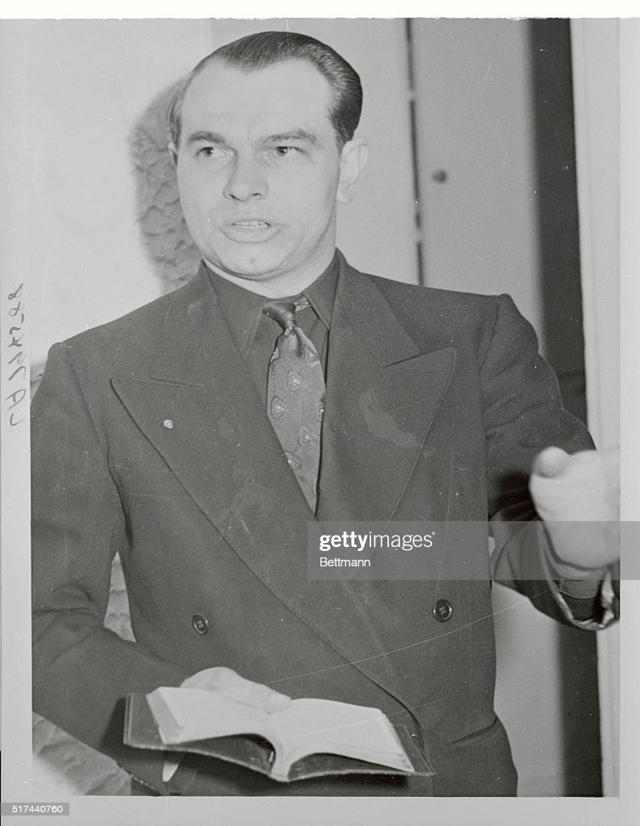

(Original Caption) Reverend Wesley Swift, pastor of a Lancaster, California church, allegedly admitted his membership in the revived Klu Klux Klan. The pastor's appearance at a recent American Legion meeting at Big Bear Lake, California, resulted in an investigation by attorney Robert W. Kenny.

<https://www.gettyimages.com/detail/news-photo/reverend-wesley-swift-pastor-of-a-lancaster-california-news-photo/517440760>

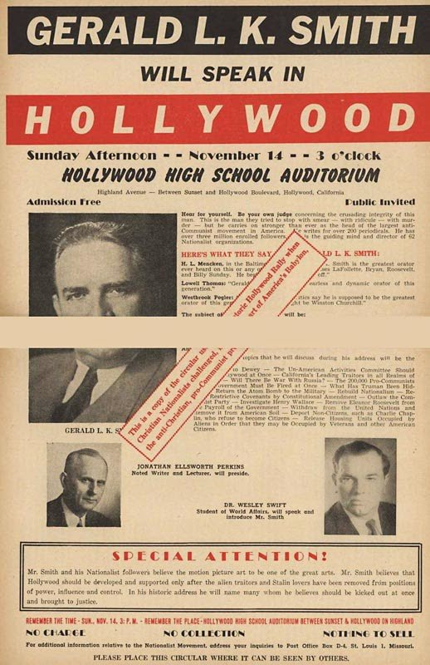

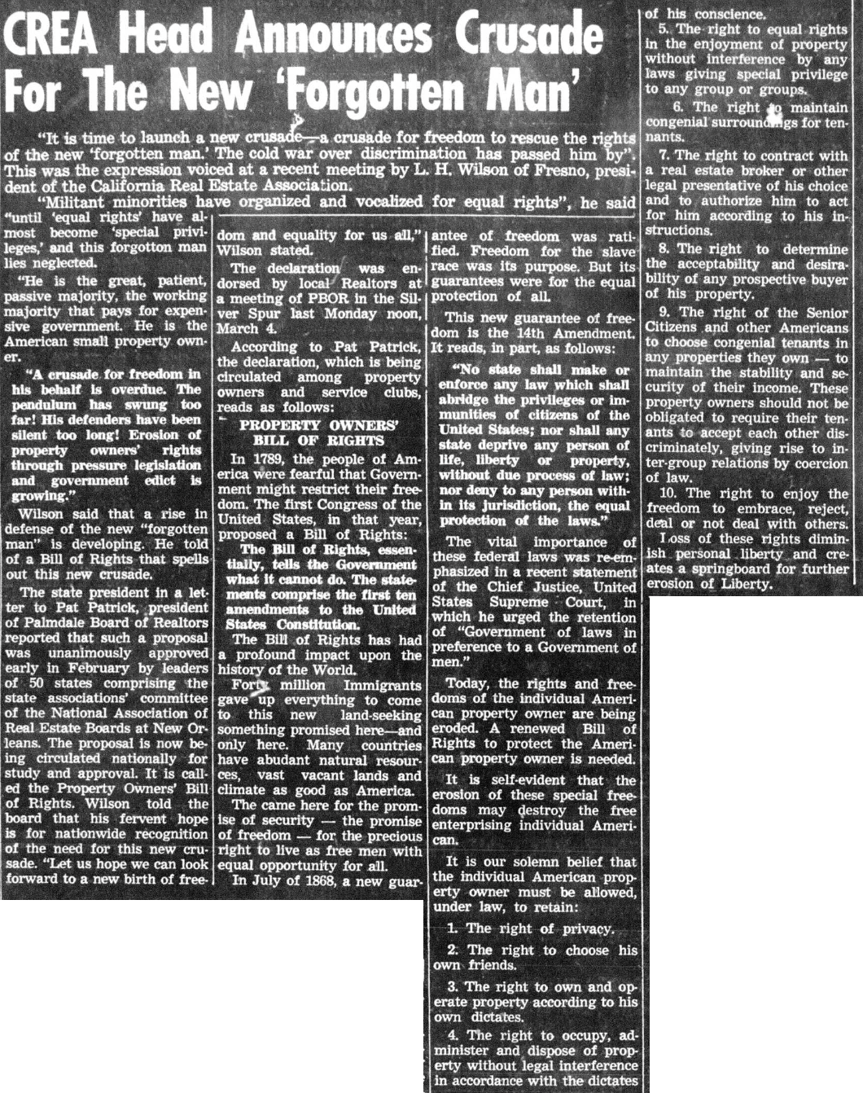

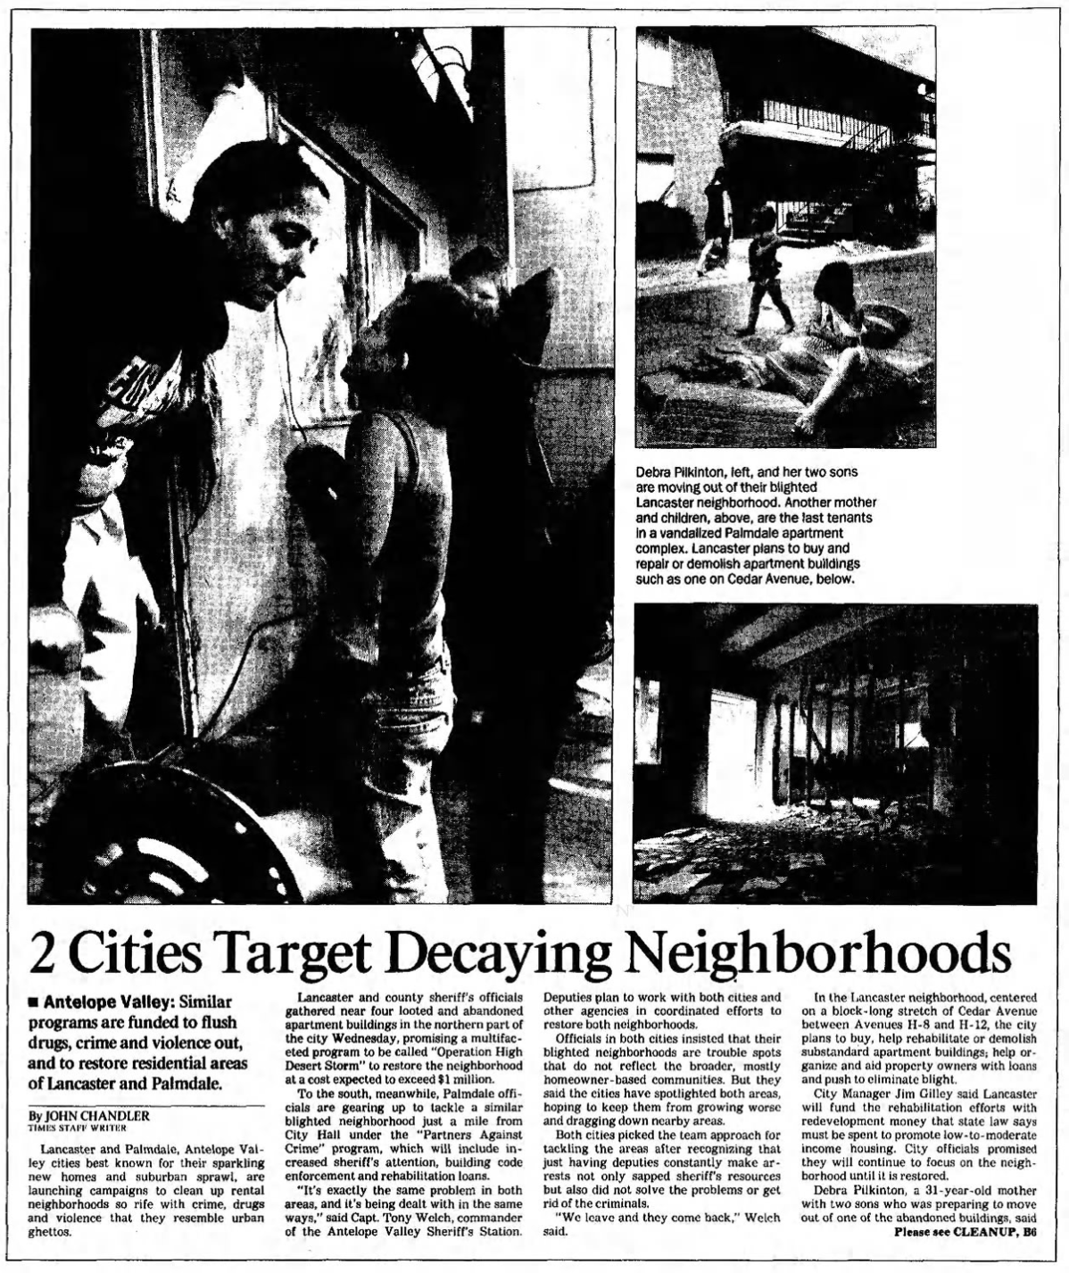

Operation High Desert Storm

1. Michael Barkun, *Religion and the Racist Right: The Origins of the Christian Identity Movement* (Chapel Hill: University of North Carolina Press, 1997), . See also, Dianne Dentice, “Hate Speech, Prejudice, and Biblical Interpretations,” *Journal of Faith, Education, and Community* 3, no. 1 (2019): 3.
2. Lynn M. Hudson, *West of Jim Crow: The Fight Against California’s Color Line* (Champaign: University of Illinois Press, 2020), .Hudson, Lynn M. West of Jim Crow: The Fight Against California's Color Line. University of Illinois Press, 2020.
3. Hudson, 2020.
4. See: <http://jfk.hood.edu/Collection/Weisberg%20Subject%20Index%20Files/S%20Disk/Swift%20Wesley%20Dr/Item%2003.pdf>
5. Daniel Levitas, *The Terrorist Next Door: The Militia Movement and the Radical Right*. (New York: St. Martin’s Press, 2004), p. 24.
6. “Membership in the Ku Klux Klan,” Digital Public Library of America, <https://dp.la/item/feb18a9828280f9551d619b6e6d987c4?q=membership+in+the+klan>.
7. Jerzy Sobieraj, “‘Pure Americanism’: The Ku Klux Klan, Nativism, and the Moral Crusade in the Jazz Age,” *Polish Journal for American Studies*, 3 (2009): 107-115. https://depot.ceon.pl/bitstream/handle/123456789/8630/09_pjas3.pdf?sequence=1
8. Hiram Wesley Evans,“The Klan’s Fight for Americanism,” *The North American Review* 223, no. 830 (1926): 33–63. http://www.jstor.org/stable/25113510.
9. Levitas, *The Terrorist Next Door*, 36-37
10. “Follow L.A. Lead, Utahns Urged by Anti-Red Aid.” *Salt Lake Tribune* (Salt Lake City, UT), October 19, 1950.
11. He was a talented manipulator, organizing a speaking engagement through the masonic lodge by convincing them that the FBI had recommended him as a speaker. He walked into FBI offices to meet with the Assistant Director A.H. Belmont, and then portrayed Belmont’s taciturn reaction as secretly supportive. By 1958 he had purchased 3 new cars. He explained it by claiming to have been written into Henry Ford’s will as someone carrying out the deceased auto manufacturer’s political interests. Numerous FBI records in his file suggest that the bureau spent significant time investigating his claim that he had prophesied JFK’s death. According to FBI files, the bureau believed he was being provided with classified intelligence from a member of the Army, and sought to interview him to expose the source. Although the bureau believed that Swift also had knowledge of bombings in the South, its memos advised against interrogating him on this matter as he would be unlikely to cooperate.
12. KLAC Transcript, “The California Klan: Hotbed of Hatred.” July 15, 1965.
13. David Mark Chalmers, *Backfire: How the Ku Klux Klan Helped the Civil Rights Movement* (Lanham, MD: Rowman & Littlefield, 2005), .
14. Chalmers, *Backfire*, 175.
15. Daniel Martinez HoSang, *Racial Propositions: Ballot Initiatives and the Making of Postwar California* (Berkeley: University of California Press, 2010), .
16. “CREA Head Announces Crusade for the New ‘Forgotten Man’” *Antelope Valley (CA) Press*, May _, 1963.
17. *San Bernardino County (CA) Sun* March11, 1968.
18. *Los Gatos Times-Saratoga (CA) Observer,* April 27, 1964.
19. ‘Unitarians to Hear NAACP Guest Speaker,” *South Antelope Valley Press (CA),* June _ 1964.
20. “No on Prop 14 Essay Contest Extension Made,” *South Antelope Valley Press (CA),* September 13, 1964.
21. HoSang, *Racial Propositions*, .
22. Tyler T. Reny and Benjamin J. Newman, "Protecting the Right to Discriminate: The Second Great Migration and Racial Threat in the American West, " *The American Political Science Review* 112, no. 4 (2018): 1104-1110. See replication files for the Palmdale vote. <https://dataverse.harvard.edu/file.xhtml?persistentId=doi:10.7910/DVN/UAQZRO/1FHKS9&version=1.0> Lancaster, having not been incorporated, does not have data available.
23. “CREA Head Blasts CG Statement,” *Antelope Valley (CA) Press,* July 18, 1965.
24. “CREA Files Petition on Proposition 14,” *Antelope Valley (CA) Press,* August 28, 1966.
25. “CREA Endorses Initiative to Repeal Rumford Act,” *Antelope Valley (CA) Press,*  July 24, 1966.
26. “CREA Asks Lynch to Urge Review of “14,”’*Antelope Valley (CA) Press,* September 18, 1966.
27. Charles McC Mathias and Marion Morris, "Fair Housing Legislation: Not an Easy Row To Hoe," *Cityscape* 4, no. 3 (1999): 21-33.http://www.jstor.org/stable/20868473.
28. “Rodgers Asks Help from Realtors,”*Antelope Valley (CA) Press,*  September 18, 1966.
29. Daisy Gibson,“Sun Village Housing Proposals Discussed,” *South Antelope Valley CA) Press*, November 19, 1964.
30. “New Street Lighting Set for Village,” *Antelope Valley (CA) Press,* January 3, 1965.
31. Sebastian Rotella,“Sun Village: Black Enclave Withers Amid Antelope Bloom,” *Los Angeles Times,* August 27, 1989, https://www.latimes.com/archives/la-xpm-1989-08-27-me-1851-story.html.
32. Pittman had been president of the California State Association of Women’s Clubs from 1936-1938 and the California Council of Negro Women from 1948-1951, and director of the West Cosat Region of the NAACP from 1961-1965. She was from one of the oldest Black families in Kern County, and the first Black student to graduate from Bakersfield Junior College, before getting a BA from SF State and an MA from UC Berkeley. She also ran a radio program, “Negros in the News” on Oakland’s KDIA for 25 years.
33. “NAACP Unit Holds Officer Installation,” *Antelope Valley (CA) Press,* February 9, 1967.
34. “Dignity of Man, Topic at CREA Convention,” *Antelope Valley (CA) Press,* October 1, 1967.
35. “Reinecke Explains Stand on New Civil Rights Bill,”,.” *Antelope Valley (CA) Press*, April 18, 1968.
36. In 1974, Reinecke ran for California governor as the conservative Republican successor to Reagan but was indicted for perjury related to the Watergate scandal and lost in the primary.
37. “Education, Taxes, Crime Headline CREA Convention,” *Antelope Valley (CA) Press*, October 6, 1968.
38. [to do: add Antelope Valley College Vietnam War moratorium and Angela Davis organizing]
39. “Dr. Wesley Swift, Noted Conservative Leader, Dies.” Antelope Valley (CA) Press. October 11, 1970.
40. “Picture of Angela Davis Stirs College Controversy.” Antelope Valley (CA) Press. October 11, 1970.
41. “Richard Butler,” Southern Poverty Law Center, accessed August 17, 2022. <https://www.splcenter.org/fighting-hate/extremist-files/individual/richard-butler>.
42. From Alon Milwicki, “Baptizing Nazism: An analysis of the religious roots of American neo-Nazism,” PhD diss., (American University, 2019). “Swift’s network crisscrossed the country and not only helped Christian Identity to spread, but my analysis has revealed that there was hardly a white supremacy organization of any stripe of which Swift was not either a founder, prominent member, donor or speaker between roughly 1950-1970. He made Christian Identity his own, and his interpretation of Scripture was so far-reaching that there are still churches, organizations, gangs, and prison gangs that parrot and preach the Gospel according to Swift.” … “the man who is arguably most directly responsible for "Baptizing Nazism" and laying a foundation for Modern American Neo-Nazism to grow and thrive on the fringes of American society.”
43. “Edwards Base Jobs Discussed.” *Los Angeles Sentinel,*April 7, 1977, sec. C11.
44. Lewinnek, Elaine. "Social Studies Controversies in 1960s Los Angeles: Land of the Free, Public Memory, and the Rise of the New Right." *Pacific Historical Review* 84, no. 1 (2015): 48-84.
45. Lisa McGirr, Suburban Warriors: The Origins of the New American Right (Princeton, N. J.: Princeton University Press, 2001)
46. https://www.avc.edu/aboutavc/campushistory/TheKepleyEra#_edn26
47. “NAACP Takes Confederate Flag Mascot Fight to Lancaster School,” *Los Angeles Sentinel,* May 11, 1995, sec. A4.
48. Chris McCormick,“Op-Ed: My California High School Had a Confederate Mascot,”*Los Angeles Times,* August 24, 2017,<https://www.latimes.com/opinion/op-ed/la-oe-mccormick-antelope-valley-confederate-20170824-story.html>
49. Julie Drake, “No More Quartz Hill High Rebels: School Makes it Official; Mascot Will Be Changed,,”*Antelope Valley (CA) Press,* June 20, 2020, <https://www.avpress.com/news/no-more-quartz-hill-high-rebels/article_a641b440-b298-11ea-a951-d7c2352fd5b6.html>
50. “Record Settlement in Housing Bias Case,” *Los Angeles Sentinel*, December 19, 1991,sec. A13.
51. Finnegan 1998, p. 272
52. Finnegan 1998, p. 272
53. Finnegan 1998, p. 273
54. Davis, Mike. *City of Quartz: Excavating the Future in Los Angeles*. Verso Books, 2006, p.6
55. Werner Troesken and Randall Walsh, "Collective Action, White Flight, and the Origins of Racial Zoning Laws," *The Journal of Law, Economics, and Organization* 35, no. 2 (2019): 289-318.
56. Jeannine Bell, *Hate Thy Neighbor: Move In Violence and the Persistence of Racial Segregation in American Housing* (New York: New York University Press, 2013), .
57. The original data, referenced by Bell (2013) is in this study: Jack Levin and Jack McDevitt, “Police Response,” in *Hate Crimes* (Boston: Springer, 1993), 159-178, <https://doi.org/10.1007/978-1-4899-6108-2_12>. While I use the term hate crime in order to maintain consistency with the original study’s terminology, I also note critiques of the term and its limited, and sometimes counterproductive role in understanding violence.
58. Bell, 2013, pg 68
59. Park, K-Sue. "The History Wars and Property Law: Conquest and Slavery as Foundational to the Field." Yale LJ 131 (2021): 1062.
60. Belew, Kathleen. *Bring the War Home*. Harvard University Press, 2018.
61. Larrubia, Evelyn. 1997. “Lancaster Slaying Victim Had Feared a Racial Attack.” Los Angeles Times. November 2, pp. 1.
62. Los Angeles Sentinel. 1997. “Hate Crimes Against Blacks Up 50 Percent.” May 1, pp. A1
63. Meyer, Josh. 1994. “Flyers Spread Message of Hate in the Valley.” Los Angeles Times, January 2, pp. VYA1
64. Johnson, Josh. 1993. “Events of 1993 Cost Valley its Last Vestige of Serenity.” Los Angeles Times, December 31, pp. VYA1
65. Bender, Steven. 2003. Greasers and Gringos: Latinos, Law, and the American Imagination. New York: New York University Press.
66. Los Angeles Times. 1994. “Sometimes Just Say No: State senator accepts invitation to speak to alleged supremacists.” August 26, pp. VYB14
67. Streeter, Kurt. 1999. “2 Men Arrested in Racial Attack at Lancaster Store.” Los Angeles Times. March 25.
68. Sandoval, Greg. 1997. “U.S. Widens Role in Probe of Hate Crimes in Antelope Valley.” Los Angeles Times February16, pp. 1.
69. https://www.fcroberts.com/bio/
70. <https://www.latimes.com/archives/la-xpm-1998-jul-14-me-3633-story.html>
71. Reports of 3 Racist Incidents Are Probed in Antelope Valley; Hate: Lancaster mayor decries the burning of a swastika into the grass at city park after a celebration of diversity. Liu, Caitlin . Los Angeles Times ; Los Angeles, Calif. [Los Angeles, Calif]11 Sep 2000: 2.
72. “50 Years Of Deputy Gangs: Identifying Root Causes And Effects To Advocate For Meaningful Reform in The Los Angeles County Sheriff’s Department.” Loyola Marymount Center for Juvenile Law and Policy. 2020. <https://lmu.app.box.com/s/uci2ir4mkpudtvvfp7z8iu4kv1gre1dj>
73. The report examined the common claim that disproportionate stops are a product of disproportionate criminal activity by minority groups, and found the claim to be baseless. “The low contraband seizure rate for African Americans indicates that, overall, LASD deputies in the Antelope Valley appear to have a less accurate threshold of suspicion for searching African Americans, and that the greater frequency of searches of African Americans cannot be explained by a greater likelihood that they are carrying contraband (such as illicit drugs or weapons).”
74. “What is clear, however, is that LASD's search tactics place a disproportionate burden on African Americans in the Antelope Valley, in that African Americans are significantly more likely to be searched even if they are not carrying contraband. We know also, based upon the scores of complaints we received about LASD's search practices during our interviews of community members, that this practice is a significant cause of the divide between LASD, and Latinos and African Americans in the Antelope Valley. Over and over again, we heard disturbingly similar accounts of Antelope Valley deputies pulling over African-American and Latino pedestrians and drivers, searching their persons and/or cars, and releasing them without a citation or any information about why they were initially stopped.”
75. the number of obstruction arrests at Lancaster and Palmdale stations accounting for 25% of all obstruction arrests by LASD and exceeding the number of obstruction arrests for every other station. We examined use of force reports from August 2010 to August 2011 in which the subject was charged only with the following and no other crimes: resisting arrest or obstructing an officer in his or her duties, whether a felony, California Penal Code (PC) § 69; misdemeanor, PC § 148(a)(l); and battery on a peace officer or other public officer without the infliction of injury,

    PC § 243(b ». Of all the use of force reports reviewed, approximately 22% fit into this category.
76. The Los Angeles Times (Los Angeles, California) · Thu, Oct 8, 1992 · Page 589
77. The Partners Against Crime program continues to operate today: https://cityofpalmdale.org/249/Partners-Against-Crime-PAC
78. The Los Angeles Times (Los Angeles, California) · Thu, Oct 8, 1992 · Page 596
79. President Bill Clinton, “Remarks by the President at One Strike Symposium,” The White House, Office of the Press Secretary, March 28, 1996, available online at: <http://clinton6.nara.gov/1996/03/1996-03-28-president-remarks-at-one-strike-crime-symposium.html>.
80. <https://www.reaganlibrary.gov/archives/speech/remarks-signing-anti-drug-abuse-act-1988>
81. <https://www.baltimoresun.com/news/bs-xpm-1996-03-29-1996089072-story.html>

    <https://www.everycrsreport.com/files/20020415_RS21199_d6a607f036f9ea74a314bf3d355ffcd0a1434bf3.pdf>

    <https://www.hrw.org/reports/2004/usa1104/5.htm#:~:text=The%20Anti%2DDrug%20Abuse%20Act,who%20engage%20in%20criminal%20activity>.
82. “[The] San Bernardino County Crime Free Multi-Housing program is designed to create a safer community for citizens, improve rental property values, and deter criminals from moving into the neighborhood” ; “...the benefits of becoming a “Crime-Free” property are endless: more stable, satisfied residents, improved reputation, lower maintenance costs, lower insurance rates and increased property values” ; ‘“It creates a circle between apartment owners, tenants, and law enforcement. We want the owners to select tenants that won’t destroy their property…”’ ; “Desert Hot Springs police have announced the next class in a series designed to help rental property managers reduce crime and increase property values.”
83. The rule does not distinguish between properties with just one tenant or large apartment buildings with hundreds.
84. HOPE Fair Housing Center v. City of Peoria, No. 1:17-cv-1360 (C.D. Ill.). N.B. The author served as an expert witness in this case.
85. Peoria Police Department. No Date. “Armadillos: Starting a Trend” https://popcenter.asu.edu/sites/default/files/library/awards/goldstein/2011/11-07.pdf. Accessed February 15, 2021.
86. As Terrance Stewart described, the effect of these laws is to disproportionately exclude Black and Latino residents from living in the city: “Three years after his release from prison following a cocaine dealing conviction, Terrance Stewart was accepted to UC Riverside and began searching for a place to live near campus with his wife and 3-month-old daughter. He couldn’t find one. Facing rejection after rejection, Stewart started to realize that posted around the apartment complexes he visited were gray signs with the stenciled outlines of three homes. The logos, he later learned, meant those landlords took part in a police program that trains them how to refuse tenants with criminal histories. “It just made my world shrink,” Stewart said. Kept out of Riverside and neighboring cities, Stewart’s family rented a room in a Lake Elsinore home, a 90-minute bus ride from campus.” https://www.latimes.com/homeless-housing/story/2020-11-19/california-housing-policies-hurt-black-latino-renters
87. Jones et. al. v. City of Faribault, Minnesota. No. 0:18-cv-01643 (D.C. MN)
88. Godsil, Rachel D. 2006. “Race Nuisance: The Politics of Law in the Jim Crow Era.” Michigan Law Review 105: 505.